|  |
| --- |
|  |
| Estimation of Business Expenses |
|  |
|  |

|  |
| --- |
|  |

# Screenshot (23).png

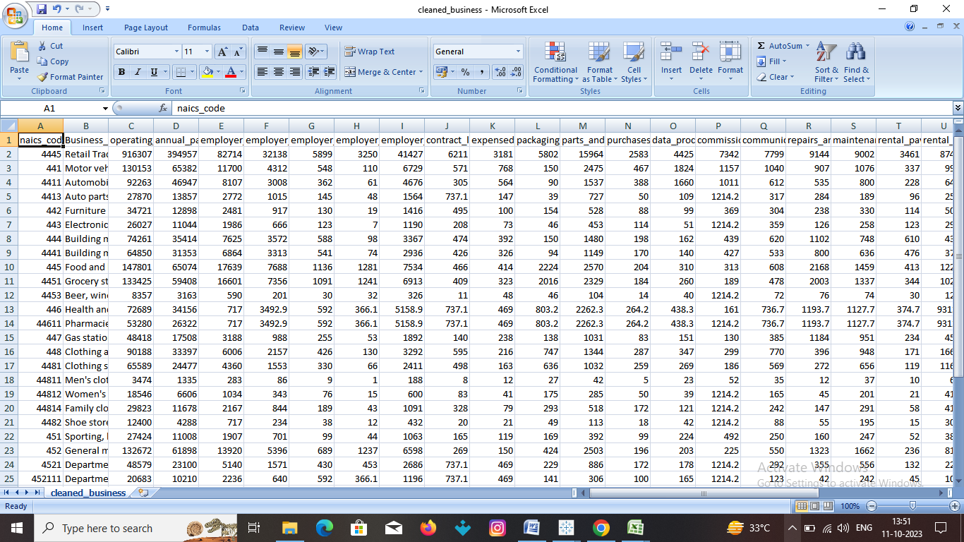

# INRODUCTION

## Overview

This Project deal’s into the fascination realm of business expenses and provides a visual exploration

Of the various expenditures incurred by different businesses .it showcases the distribution of expenses ,

Identifies key cost drivers ,and highlights areas of potential optimization or concern .Our aim is to

extract the useful information from the given data through various comparisons and visualizations.

## Purpose

The purpose of this project is to visualize the data . The visual representations allow for intuitive

analysis, facilitating a deeper understanding of expenditure patterns and their implications for business

performance. Decision-makers, financial analysts, and stakeholders can gain valuable insights into the

financial health of businesses, identify areas of inefficiency or opportunity, and make informed decisions

to optimize resources and drive growth.

# PROBLEM DEFINITION & DESIGN THINKING

## EMPATHY MAP

## Screenshot (15).png

## Ideation & brainstorming map

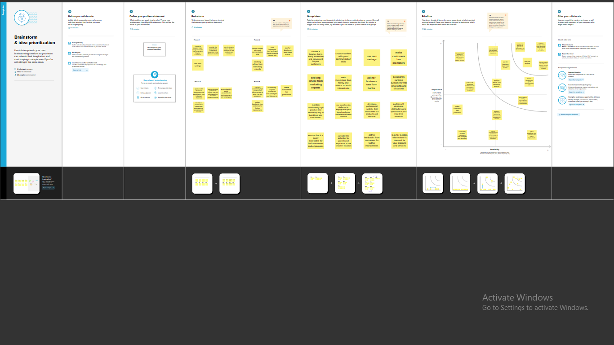

# RESULT:

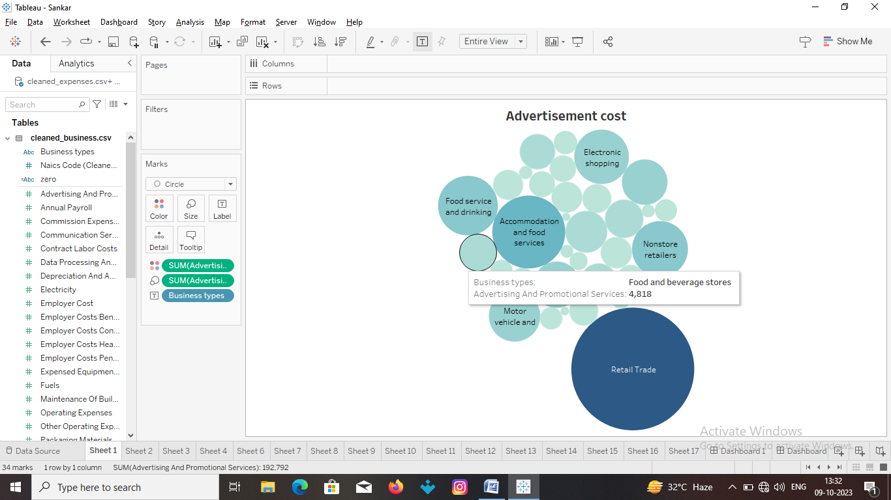

Advertisement Cost: This packed bubble chart

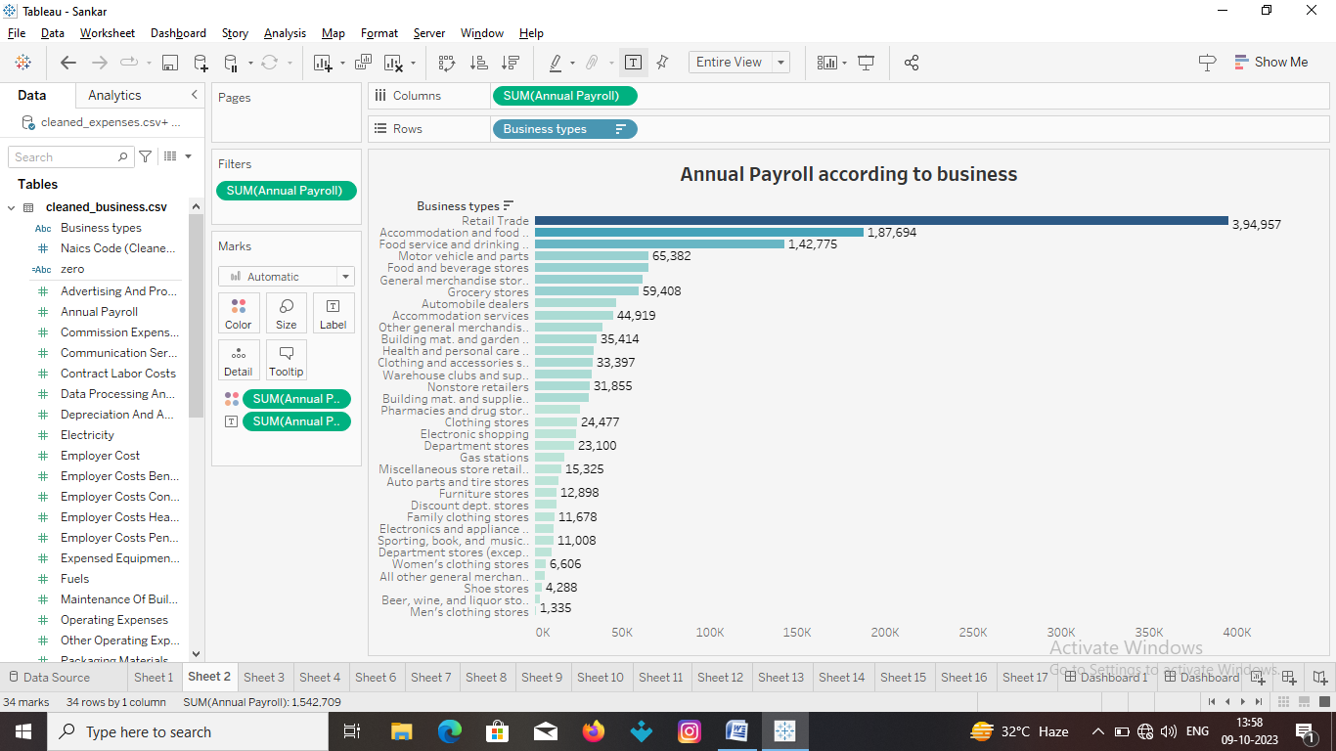

Annual Pay Roll: This bar chart define annual payroll according to business

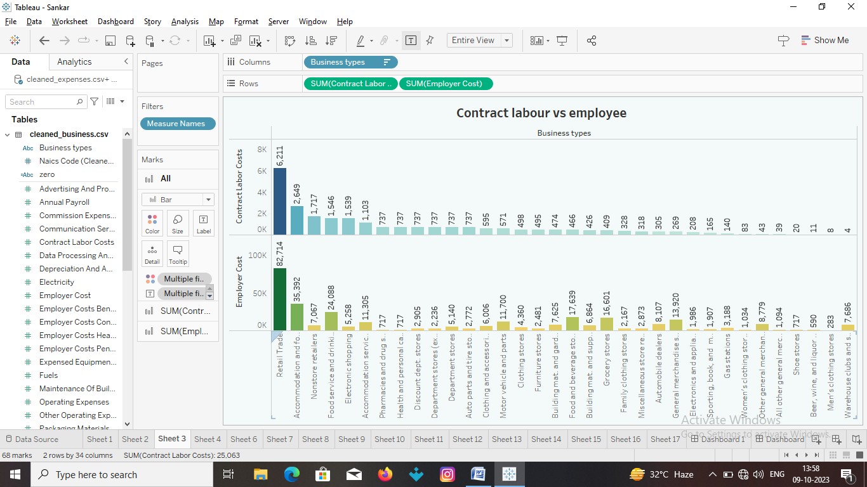

Contract Labour Costs vs Employee Cost: Difference between both workers.

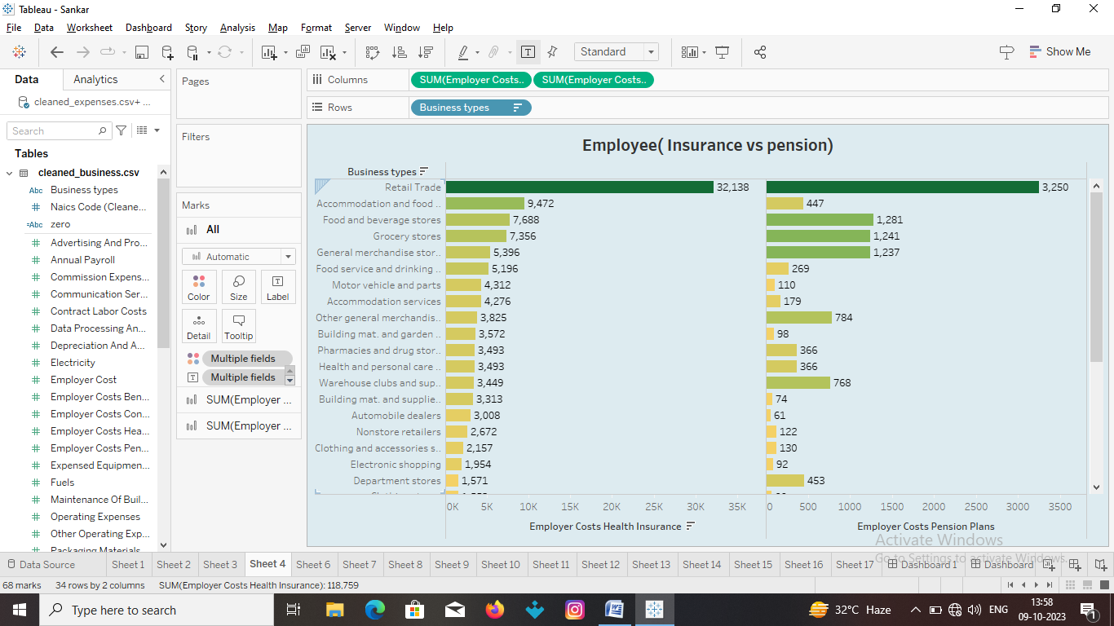

Employee Costs: This split bar chart provides a comparison by expenses for health insurance and pension plans for their

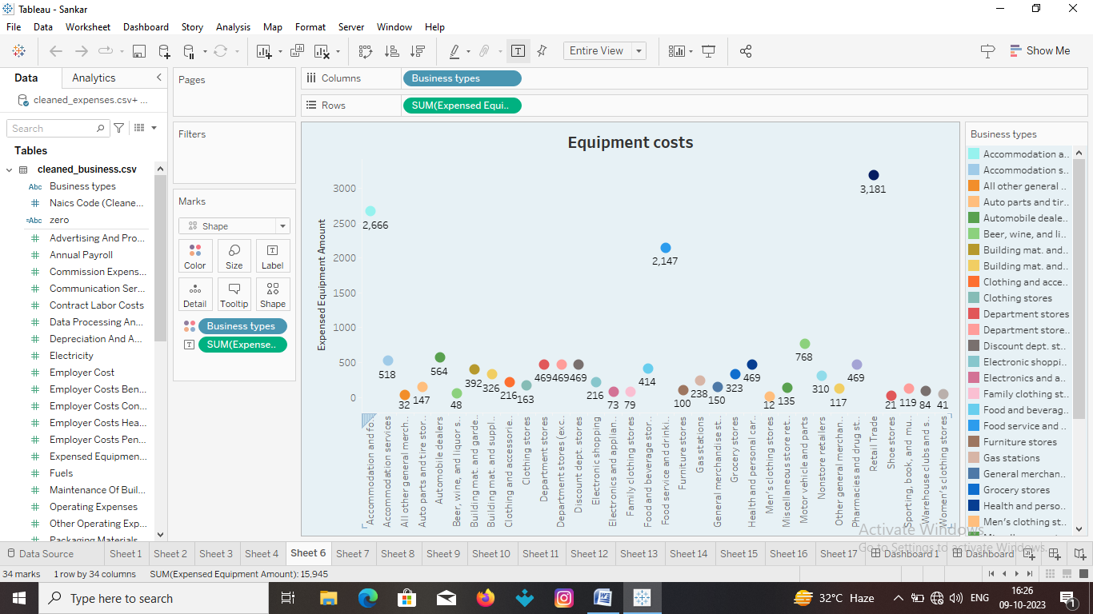

Equipment Cost: This bubble chart visualizes the expenses of equipment amount.

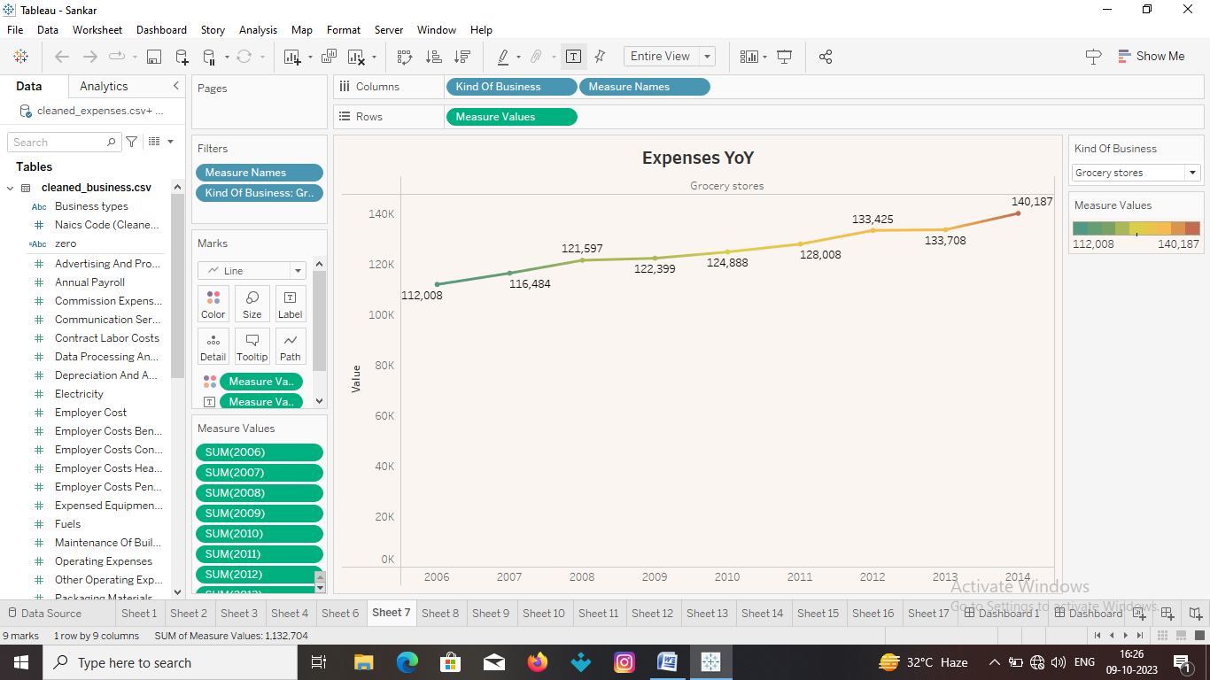

Expenses YoY : This line chart presents the expenditure amount of money spent by each business specifically from 2006 to 2014.

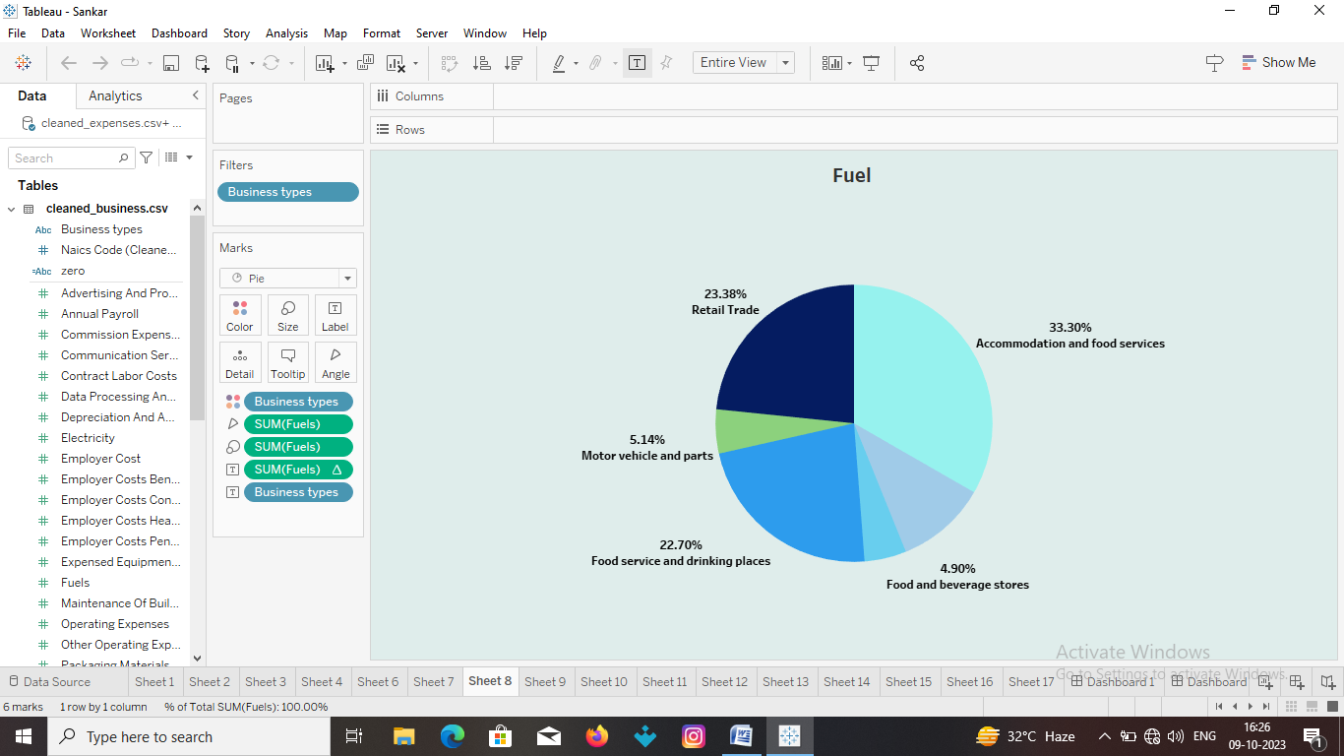

Fuel: This pie chart illustrates the expenditure allocated by percentage of these costs

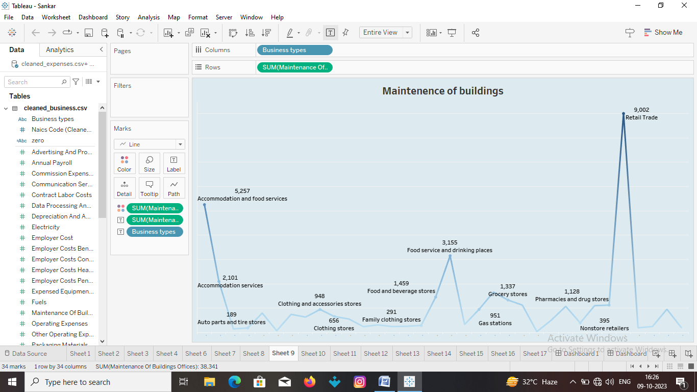

Maintenance: This line chart illustrates the incurred by each business for the maintenance of their buildings and offices. It provides a visual representation of the amount spent in this specific category

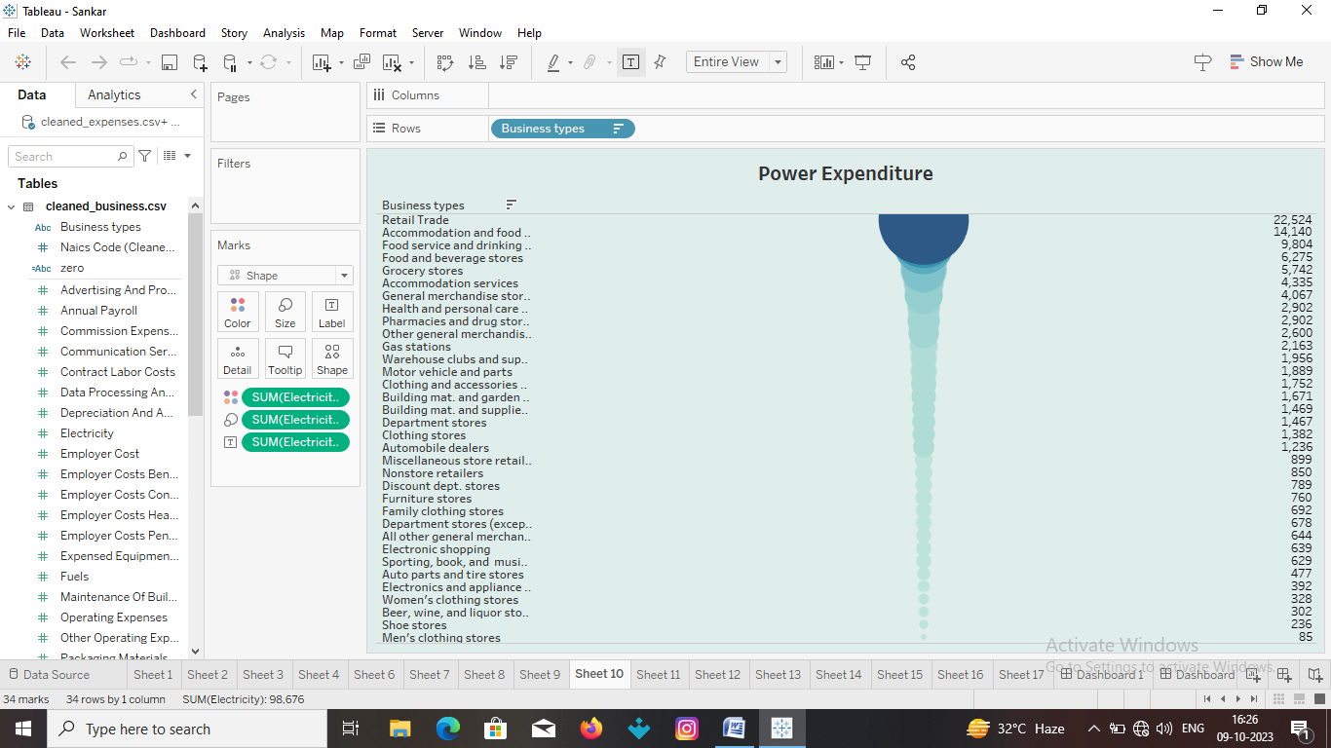

Power Expenditure: This chart explain power expenditure of costs

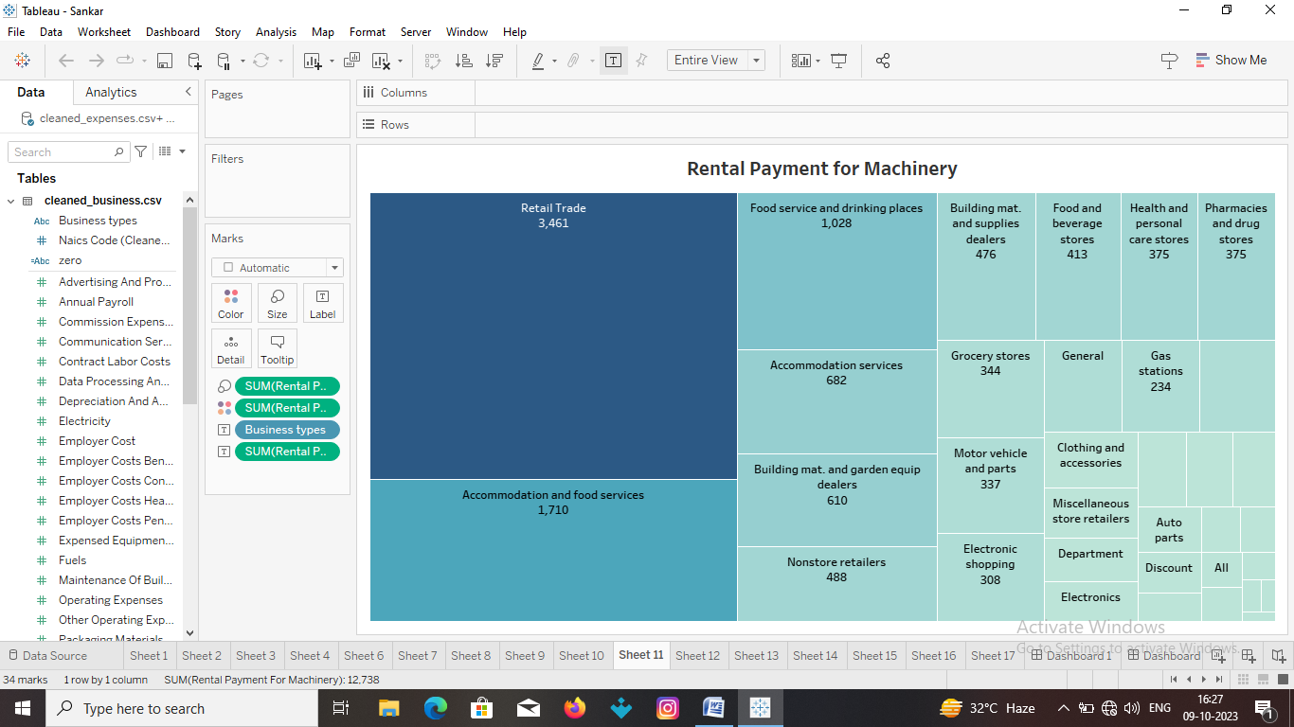

Rental (Machinery): This tree map illustrated the expenditure on the rental payment.

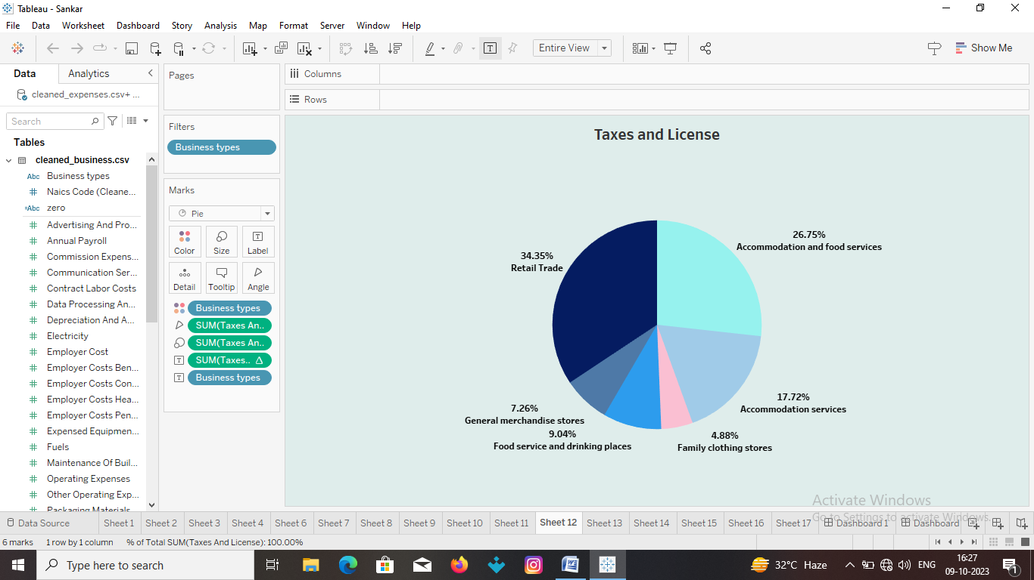

Taxes & Licenses: This pie chart illustrates the proposition of expenditure towards percentage of these costs

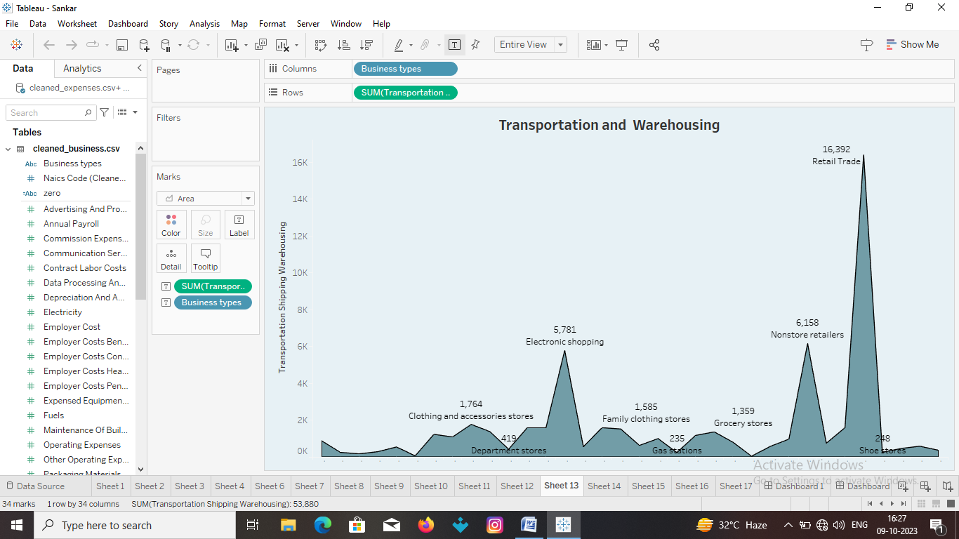

Transportation :This density map portrays the expenditure on transportation and warehousing distribution intensity of costs in these areas

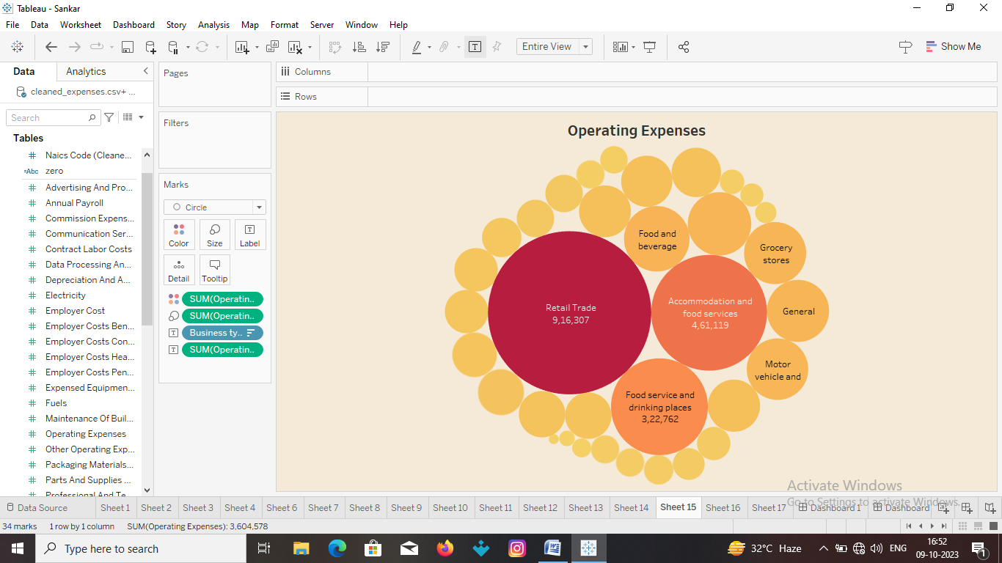

Operating Expenses: This bubble chart explain the operating expenses their costs

The above visualization provide the deep insight of the given data .These information gave the idea to decrease the expenses of the business .

# ADVANTAGE & DISADVANTAGE

## ADVANTAGE

The advantage of this project is that we got the information from the given data to

reduce the expenses of the business.

## DISADVANTAGE

The data missing from the data drive . Here data description is not available .The

data description should be provided .Then it gives more idea about the project to work.

# APPLICATION

The data given the analytics of the expenses in business .This is very helpful in

real time business problem .This project gives the idea to decrease the expenses of the business.

# CONCLUSION

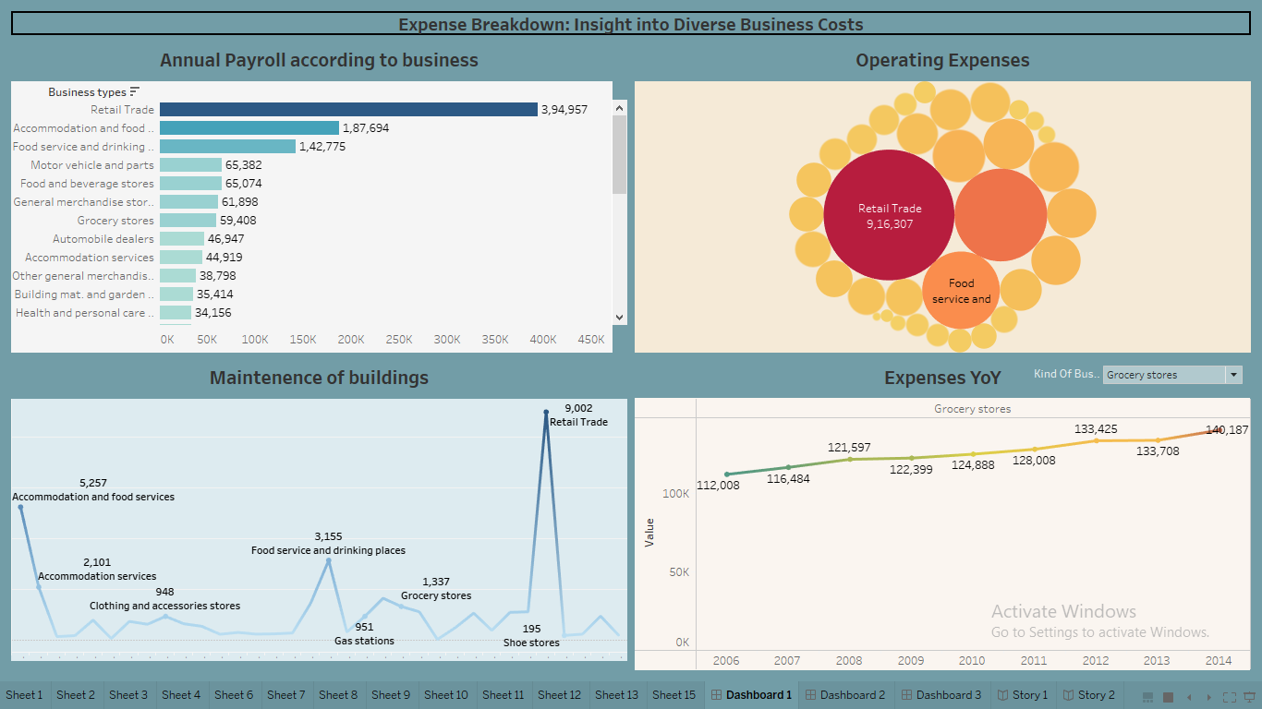

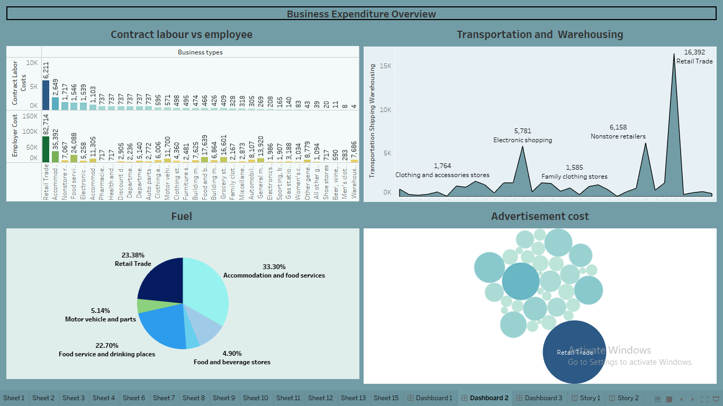

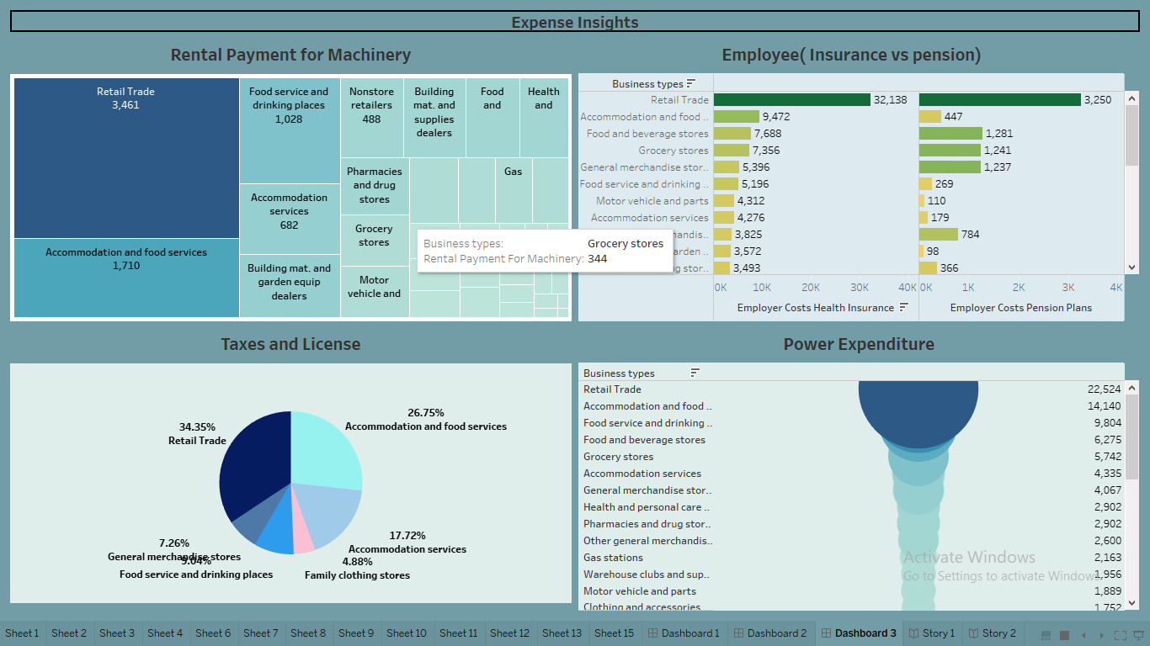

The above visualization provide the deep insight of the given data .These information

gave the idea to decrease the expenses of the business .

# FUTURE SCOPE

The data description should be provided .Then it gives more idea about the project to work. The no of business given in this project 34 . In future we may try to analyze more no. of businesses by using tableau.